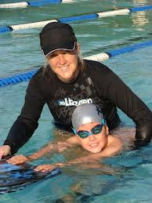

**The important factor of and adolescent/adult positive relationship is that there is a smaller risk of at-risk behaviours.**

**Assets and protective factors in youth’s development are:**

1. **support**
2. **boundaries and limits**
3. **structured use of time**
4. **educational commitment**
5. **positive values**
6. **social competence**

**All of the above can be supported/monitored by an adult whose interest is positive adolescent development.**

20% – 25% of adolescents aged 10 to 17 years old suffer from risk behaviours such as:

* dropping out of school
* alcohol/drug abuse
* delinquent behaviour
* young parenthood

Circle of Support

(SEL model)

Social-Emotional Learning

Besides parents, what other adults are role models to our children?

Extended family (grandparents, older siblings, step-parents, aunts, and uncles), neighbours, teachers, youth workers, clergy, coaches are a few examples of adults who can play a positive role in adolescents’ development.

Warning:

According to various research results more than 75% of adolescents have one close extended family member and more than 60% of adolescents have one close nonrelated adult in their lives.

Girls have more extended family or nonrelated adults more often than boys do, and these adults are often opposite sex.

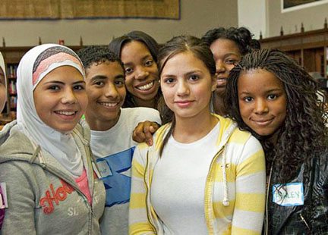

When students from grades 5 to 9 reach out to teachers and counselors, it is to talk about school related concerns or drug/alcohol problems.

Three reasons adolescents seek out teachers are:

1. to discuss personal problems
2. to ask advice (school or work related)
3. to share school related interests (academic and athletic)

“Teachers who create a warm and friendly classroom are the most successful in student learning” (P.C. Scales and J.L. Gibbons, 1996, p. 375).

### Teachers are generally not important adults in adolescents’ development unless these adolescents are high academic achievers, have high athletic ambitions/capabilities, or have educational concerns. In fact less than 10% of adolescents consider a teacher their mentor, an adult to turn to.

Kathryn R. Wentzel from University of Maryland College Park studied students’ perceptions on two questions:

* Do caring teachers affect social/academic outcomes?
* What is a caring teacher according to students?

There were 375 participants who entered the study. The research took 2 years from students’ grade 6 to grade 8 levels. Based on the results, which were collected from students, there is evidence that students will more likely participate in classroom activities if they feel supported and valued. Therefore, as teachers, we need to focus on relationship.

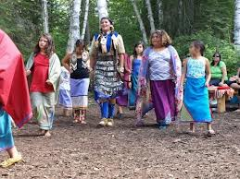

Low-income adolescents are more likely to seek out mentors at school.

When is a teacher most important in a child’s development? The research is mixed. Does a teacher become more important as a child changes into an adolescent or the other way around?

There are assumptions that caring teachers produce motivated students. Students will not learn unless there is a supportive, caring environment in the classroom.

Students generally find that teachers who care strive to make learning interesting.

Caring teachers also encourage further discussion, offer help, and notice students.

Functions of an extended family or non-related adult are:

* teacher-model
* guide-supporter
* challenger
* controller-antagonist
* pal-companion
* enabler-believer

Poverty stricken, racial-cultural minorities tend to reach out to non-parental adults more often than other adolescents. Examples are non-gang African American boys and Latina girls (95%) and African American girls (53%).

Urban adolescents see extended family and non-related adults more often than their suburban counterparts.

Question:

In neighbourhoods with low income, drug and alcohol abuse, single parent families, youth pregnancy and high crime high rates, the youth often seek out mentors in the community. If such mentors belong to that community, how can they provide support while struggling with the same problems?

Potential answer:

These adults are referred to as gifted and wizards, since they facing a tremendous task.



Teachers who yell, ignore their students and interrupt them do not care.

Also, teachers who do not explain things further, who do not answer questions or do not offer more help are not caring teachers, students say.

(K. R. Wentzel, 1997, p. 416)

Support provided by non-parents is similar to the support expected from parents.

Who does not care?

Who cares?

Today there is still not enough research in a lot of aspects of the positive relationship between adolescents and extended family members and nonrelated adults. Here are the suggested topics for further research:

1. Longitudinal (lasting a certain amount of time) studies are needed to assess adolescents’ development while being mentored by an adult.
2. Greater diversity samples of gender, ethnicity, and social-economic status need to be used in further studies.
3. There has to be a larger number of adolescents participating in each study.
4. Usually adolescents’ self-reports are used in the existing studies. Different measures are needed that would include relevant adults’ participation as well.
5. Many adolescents are not reporting in different studies (absent from school on the day of the research follow up etc.). More precision needs to be used in measuring results.
6. There has to be a bigger variety of questionnaires developed for adolescents’ self-reports.
7. There should be research on actual interactions between adolescents and their adult mentors.
8. Common understanding (a specific study) of what it means to be a caring teacher (for example) needs to be developed.

Once there is more research in this field, adolescents’ development in all venues, cultures, social-economic backgrounds could vastly benefit from close, trusting relationships with non-parental adults.

(Continued)



Adults as Supporters in Adolescents’ Lives

Knowledge Translation

Marta van de Mond

EPSE 585

University of British Columbia



References:

Scales, P., & Gibbons, J. L. (1996). Extended

family members and unrelated adults in

the lives of young adolescents: A research

agenda. *Journal of Early Adolescence, 16,*

365-389.

Wentzel, K. R. (1997). Student motivation in

middle school: The role of perceived

pedagogical caring. *Journal of*

*Educational Psychology, 89,* 411-419.

Teachers need to focus on students’ well being first before attempting teaching.